NAME | JASMINE T. ELEDEROS
PROJECT TITLE | JAS-MINE: An Integrated ERP-Based Knowledge Management System for Barangays
SUBJECT:  CODE:  TIME: | IT15/L Integrative Programming and Technologies  8478  5:30E – 7:30E
TOPIC (Type of Business Process) | #4 Knowledge Management Systems
Products/Services | Barangay / LGU
Deployed Link / Website link | http://jasmine.runasp.net/
2nd Deliverables-1st Hands-on Exam (Deployed Protype/Design)
Log in-Page | 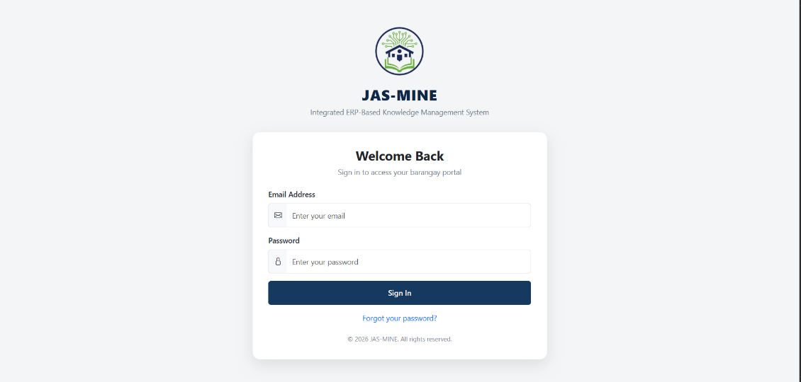  Description  The layout of the login page is consistent with the system’s logo and title, followed by a simple and clean form placed at the center of the page. The form is accompanied by an email address and password, a sign-in icon, and a password recovery feature. The whole layout is user-friendly and professional to help barangay workers effectively use the system.  Function  This web page acts as the entrance point for the whole application. It validates the user’s credentials and only allows authorized users to log in to the application. This page also performs an authentication function, allowing authorized users to access barangay important data. After successful login, the user will be redirected to their designated dashboard depending upon their roles.
Dashboard (Admin) | 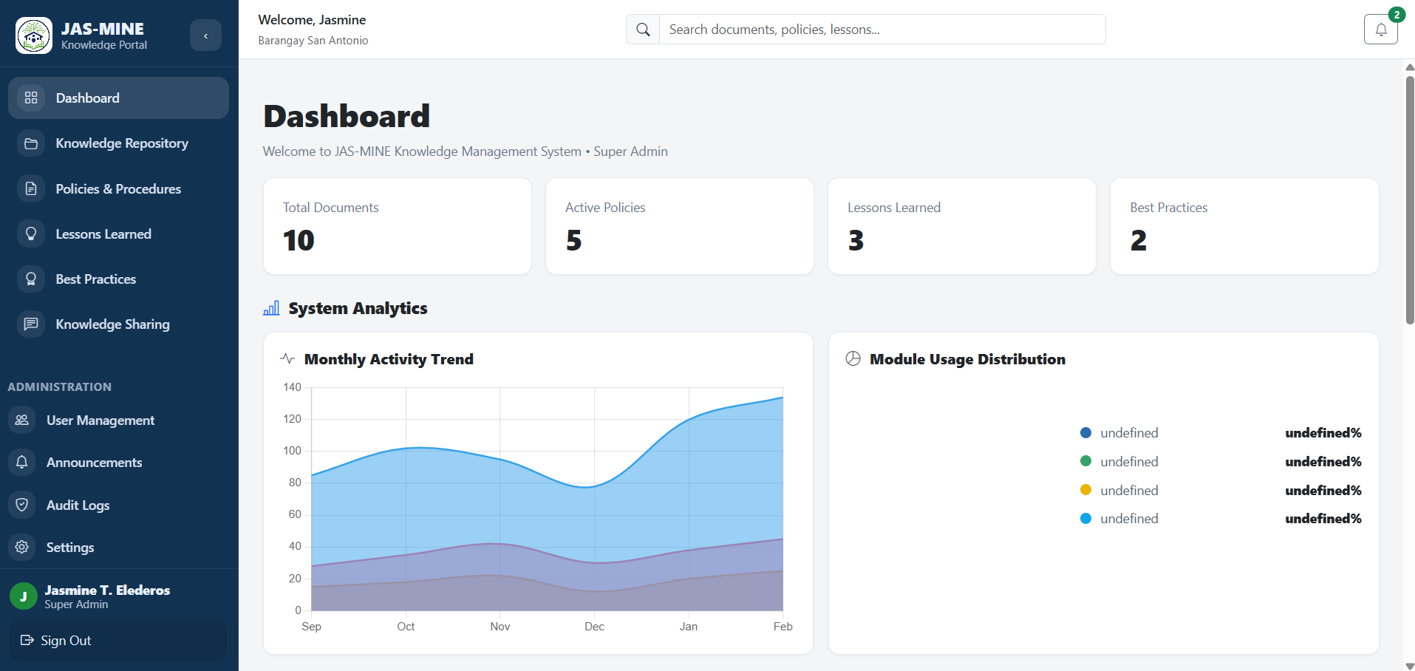  Description  The Super Administrator has access to the Super Admin Dashboard, which has a side menu bar with various module names such as Dashboard, Knowledge Repository, Policies & Procedures, Lessons Learned, Best Practices, Knowledge Sharing, User Management, Announcements, Audit Logs, and Settings. The main panel has summary cards such as total documents, active policies, lessons learned, best practices, analytics such as trends, and module usage charts.  Function  This dashboard will give us a glimpse of the whole system. It will enable the Super Admin to monitor all barangay activities, manage users and roles, as well as look at reports and system logs. It will be able to track the performance and usage of different modules, which is important for centralized management and accountability for all users and barangays.
Dashboard (Client/End-User) | 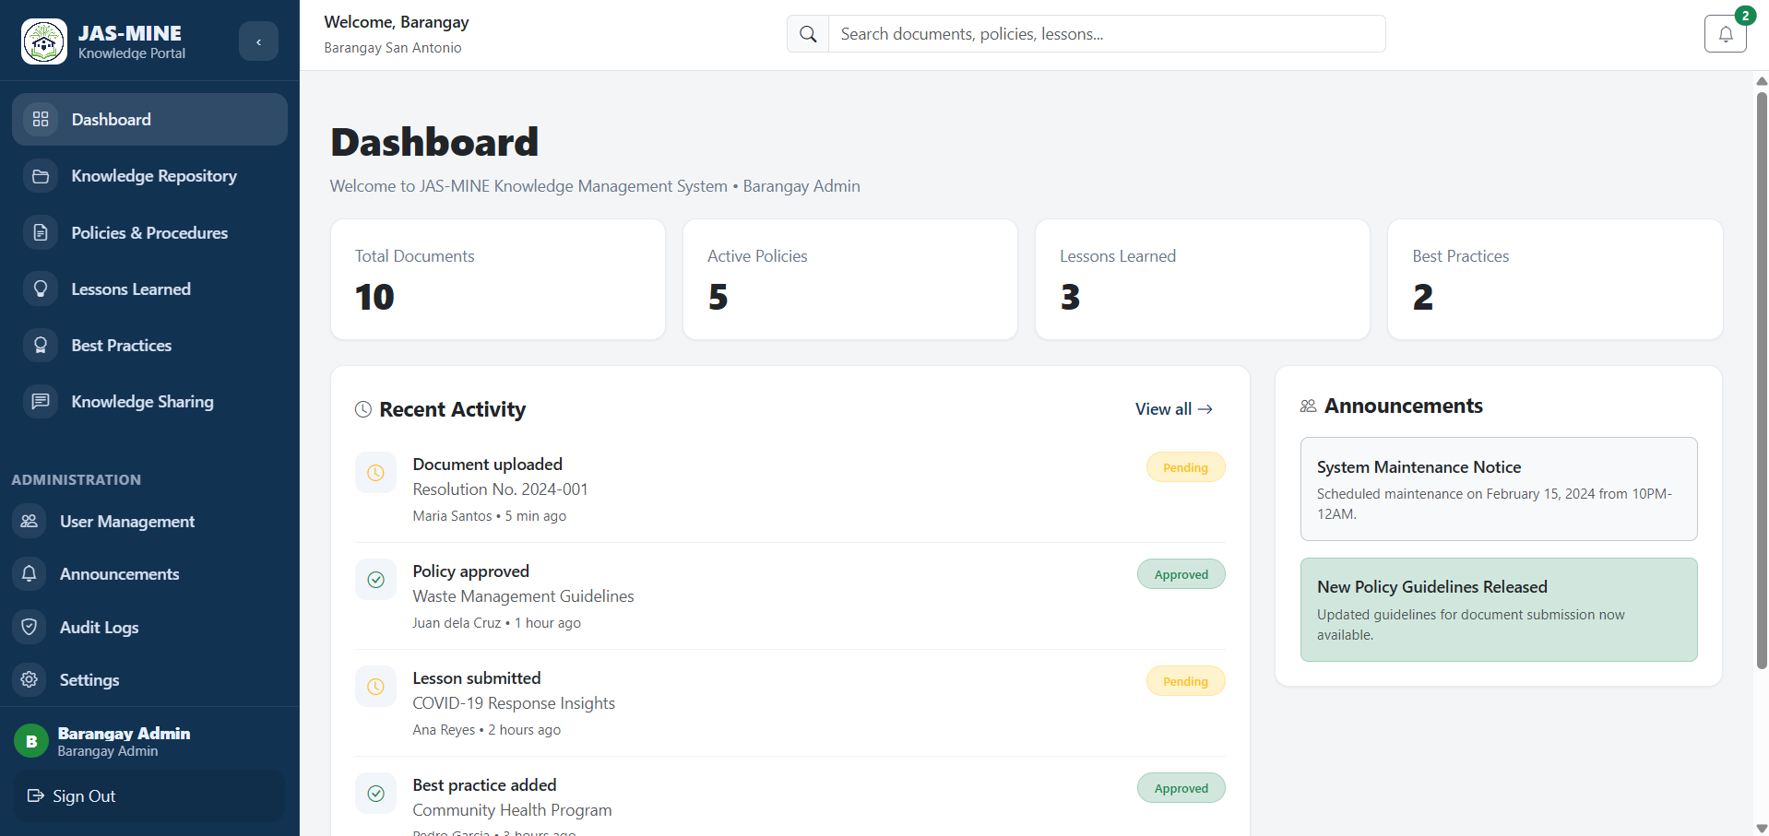  Description  The similarity of the Barangay Administrator dashboard lies in the layout, but the contents are focused on day-to-day activities. There are summary statistics and a list of recent activities, detailing uploaded documents, approvals, and submissions. Additionally, a section for announcements is included for important announcements and notifications. The sidebar links the system modules.  Function  This tool will help the Barangay Administrator manage documents, approve or deny documents, update policies, and monitor the activities of staff members. This tool can help alleviate the workload in barangay operations in terms of organizing work every day, ensuring that documents are reviewed properly, as well as keeping users informed with announcements.
Add / Create Page | 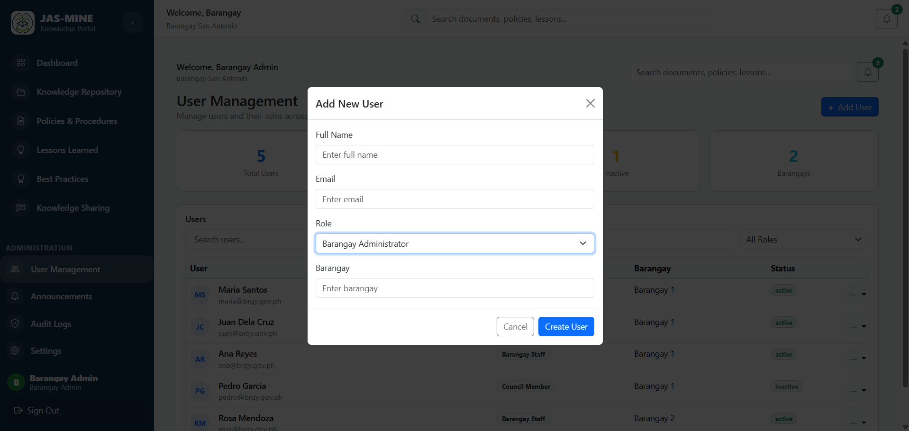  Description  The User Management page displays users currently in the system with their respective roles, barangay, and status. There is also a form window designated as “Add New User” where the administrator has the option to input the full name, email, roles, and barangay before adding a user to the system. There is also an easily navigable layout, including the sidebar and the table layout to properly organize and monitor users.  Function  This tool can also be utilized by the administrator in managing all the users of the system. Adding new users can be done through this function, as well as controlling the responsibilities of the users through the implementation of roles and permissions. This increases the security of the system since authorized users can only use certain modules of the system.
Update/Edit Page | 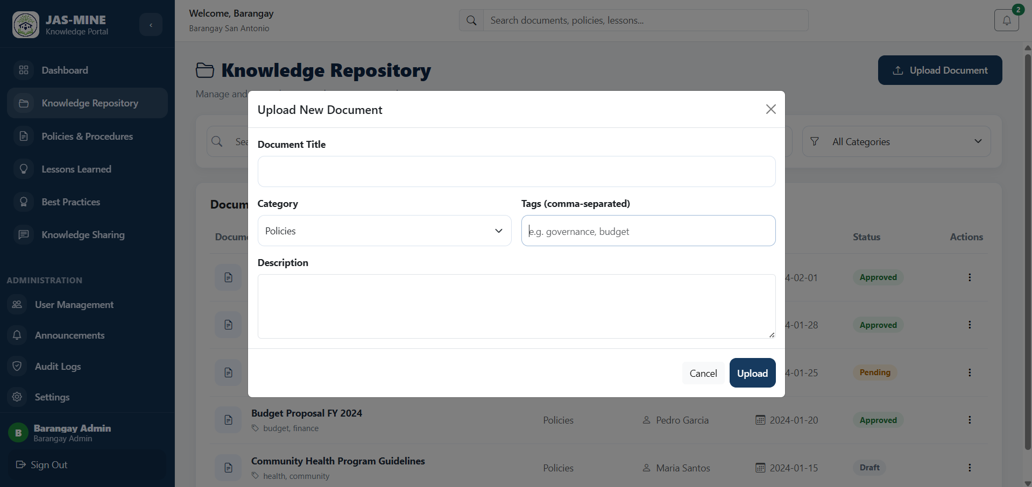  Description  The Upload Document screen has a form displayed within the Knowledge Repository facility, wherein users can enter information required for a document, like title, category, tags, and description, among others. This will be shown as a pop-up screen with options for canceling or uploading the data. It is meant for entering all information before uploading the file to the system.  Function  The tool will allow authorized users to upload official barangay documents such as resolutions, ordinances, and policies. The tool will help organize these documents according to category and make them searchable using tags. In addition, the tool ensures that all documents are stored securely to organize records.
Display Records | 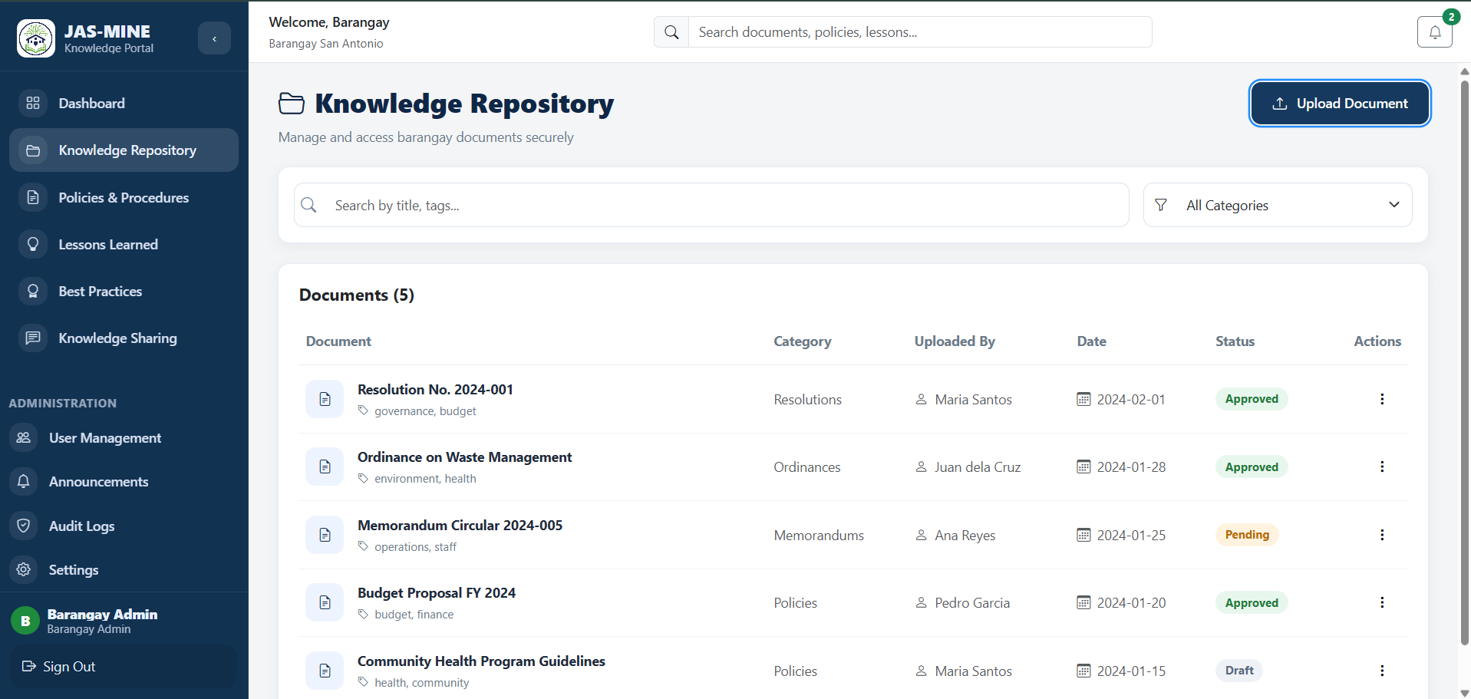  Description  The Knowledge Repository section will show a list of uploaded documents in a neat and organized manner with a search box, filters, and a table containing document names, categories, uploaders, dates, approved, pending, or draft status, and so on. The sidebar will facilitate easy access to other system components.  Function  This tool would be used as the storage system that holds all knowledge related to the barangay. Users can use it to easily find information, view it, and track it, as well as ensure that they have access only to the latest version.
Date Submitted: | February 12, 2026
Teacher’s Feedback | _________________________________________________________________  _________________________________________________________________  _________________________________________________________________  _________________________________________________________________  _________________________________________________________________  _________________________________________________________________  ________________________________ __________________________  Student’s Signature (after feedbacking) Teacher’s Signature

